Practical no 9

Create the Data staging area for the selected database using SQL.

a] Create a staging database and a staging table:

create database staging;

use staging

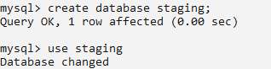

create table stage_primary_data(id int(3) primary key auto_increment,name varchar(50),address varchar(40),pin varchar(5));

describe stage_primary_data;

insert into stage_primary_data(name,address,pin) values ("Kalpaj Phansalkar","Kankavli",'412');

insert into stage_primary_data(name,address,pin) values ("Tejas Redkar","Kankavli",'35');

insert into stage_primary_data(name,address,pin) values ("Sairaj Patkar","Kudal",'6969');

insert into stage_primary_data(name,address,pin) values ("Ricky Fernandis","Kasal",'11111');

select * from stage_primary_data;

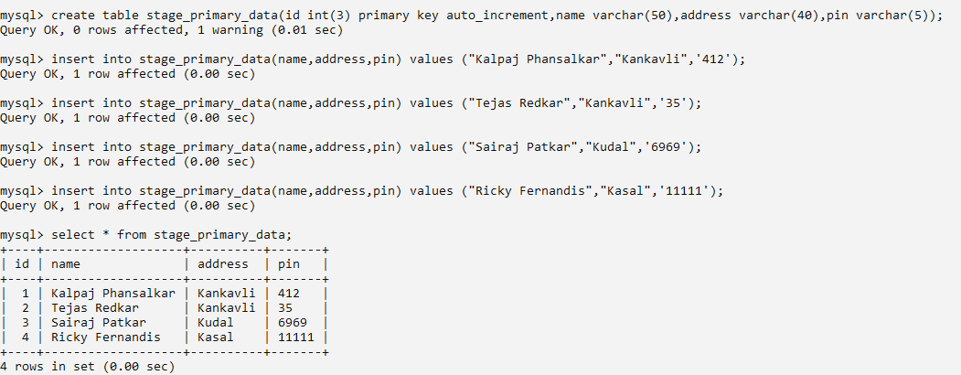

update stage_primary_data set pin=right(concat("00000",pin),5);

select * from stage_primary_data;

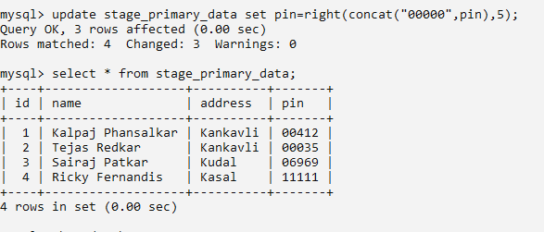

b] Create a database for data storage:

create database data_storage;

use data_storage;

create table process_primary_data(id int(3) primary key auto_increment,name varchar(50),address varchar(40),pin varchar(5));





c]insert the data into the other database from the staging database:

INSERT INTO process_primary_data SELECT * FROM staging.stage_primary_data;

select * from  process_primary_data;

